# **Starting with CAN-report**

# Introduction

Before connecting the probe to any of the CAN bus, please **care about the size of the bus cable** you intend to observe (CAN A or CAN B). If the cable is **the biggest gray one**, you just have to **SWITCH ON the switches which are to the extremity of the connection**, and **SWITCH OFF the others**. If the cable is **the smallest one**, you will have to **put or remove jumpers on Janus cards**, in order to terminate the line.

The easier way to observe something on the bus is the following :

||||||||--------------------------||||||||---------------------------||||||||--------------------------||||||||

PC 1 ON NOTHING PROBE ON PC 2 ON

But you can also have the next configuration :

||||||||--------------------------||||||||---------------------------||||||||--------------------------||||||||

PC 1 ON PC 2 OFF PROBE ON NOTHING

**ON means** that you must activate the line termination, either by **switching ON the switch for the biggest gray cable**, or by **putting the jumper TL on the PC Janus card for the smallest cable.**

On the contrary, **OFF means** that you must deactivate the line termination, either by **switching OFF the switch for the biggest gray cable**, or by **removing the jumper TL of the PC Janus card for the smallest cable**.

# Steps

1) Plug the probe to the CAN bus you want to observe (CAN A or CAN B) and the USB port to the laptop. Launch CAN-Report Software.

2) Configuration : **Connection > CAN-Interface**

Put the following parameters : (**Can Interface : CPC** and **Baud rate : 1000**)

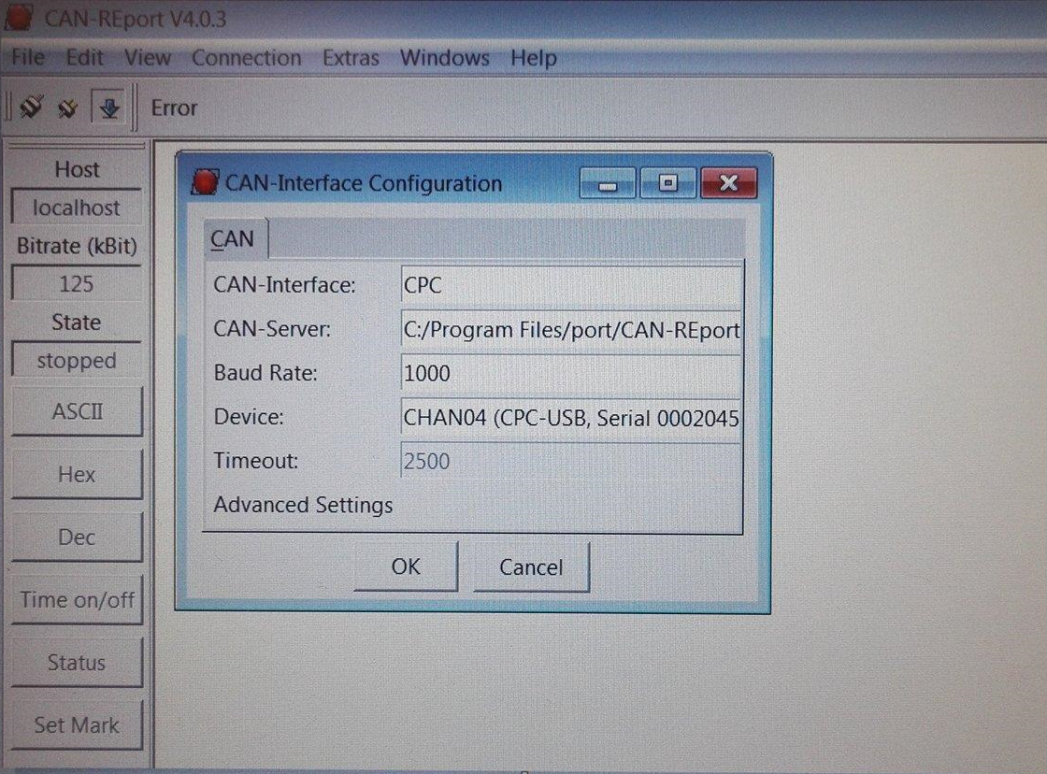

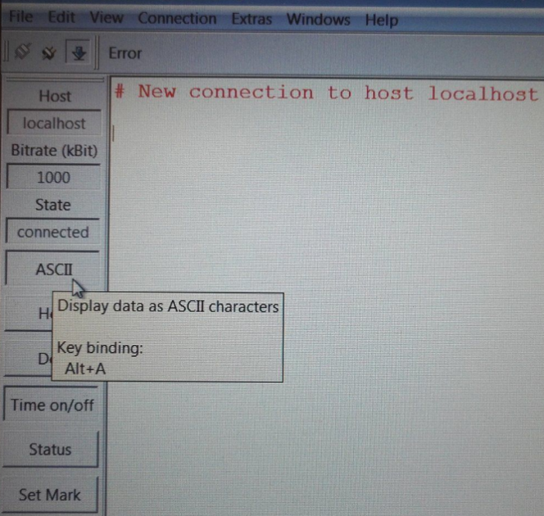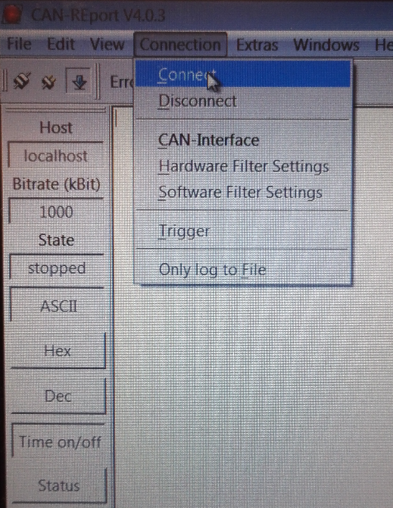3) Click on **Connection > Connect** and choose the decoding method. (Here ASCII because the functions (sendFloat and receiveFloat) used in the code transmit the data in ASCII, for more details refer to the code of these functions)

4) Launch your program. Information passing on the CAN bus will be decoded and displayed on the CAN-Report interface as follow:

- first column : date of transmission

- last column : data displayed in the chosen format

Example bellow: PC1 send throught the CAN bus to PC2 a step (150) at t=0 and PC2 respond to PC1 with the output of a 1st order uncorrected system with a unit gain subject to this step.

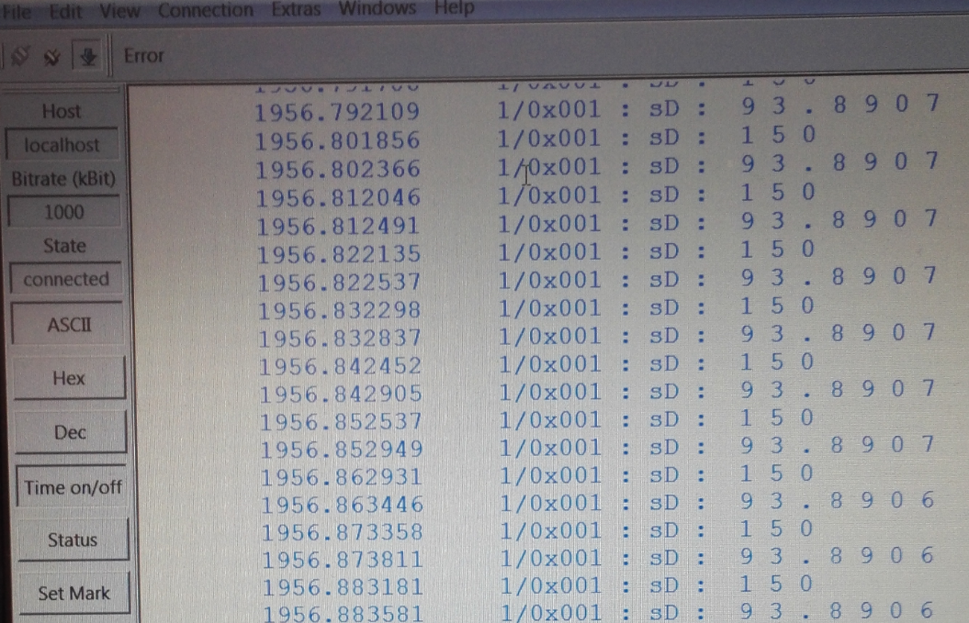

Exchange are done step by step and numeric values are in ASCII.

However we don’t know just by looking at CAN-Report in which ways the data are transiting.